--Q1--

CREATE PROCEDURE ShowAverageSale

AS

BEGIN

SELECT TOP 1 tblDepartment.NAME AS Name, MIN(AverageSal) AS MinAverage FROM

(SELECT tblEmployee.DEPTID, avg(tblEmployee.SALARY) AS AverageSal

FROM tblEmployee

GROUP BY tblEmployee.DEPTID

) AS DeptAverage JOIN tblDepartment ON tblDepartment.ID=DeptAverage.DEPTID GROUP BY tblDepartment.NAME

ORDER BY MinAverage ASC

END

EXEC ShowAverageSale

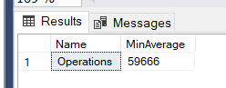

--Q2--

CREATE PROCEDURE SaleLessThan @SALARY INTEGER, @DEPT VARCHAR(255)

AS

BEGIN

SELECT tblEmployee.FIRSTNAME,tblDepartment.NAME FROM tblEmployee JOIN tblDepartment ON tblDepartment.ID=tblEmployee.DEPTID

WHERE tblEmployee.SALARY<@SALARY AND (tblEmployee.DEPTID=tblDepartment.ID AND tblDepartment.NAME=@DEPT)

END

EXEC SaleLessThan @SALARY=75000,@DEPT='Marketing'

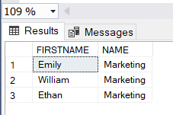

--Q5—

CREATE FUNCTION SumSalDept (@NAME VARCHAR(255))

RETURNS INTEGER

AS

BEGIN

RETURN (SELECT AVG(tblEmployee.SALARY) FROM tblEmployee

JOIN tblDepartment ON tblDepartment.ID=tblEmployee.DEPTID

WHERE tblDepartment.NAME=@NAME);

END

SELECT DBO.SumSalDept('IT') AS AvgSal

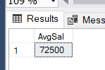

--Q4--

CREATE TRIGGER trgAfterInsert_tblEmployee

ON tblEmployee

AFTER INSERT

AS

BEGIN

INSERT INTO tblLog(ACTIVITY, DateEntry) VALUES ('New employee added', GETDATE());

PRINT'NEW DATA ENTERED'

END;

INSERT INTO tblEmployee (ID, FIRSTNAME, LASTNAME, SALARY, DEPTID) VALUES (23, 'Emily', 'Brown', 65000, 3);

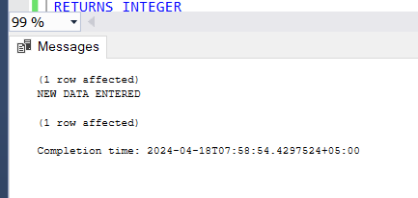

--Q3--

CREATE TRIGGER SAFTY

ON DATABASE

FOR

CREATE_TABLE

AS

BEGIN

PRINT 'TABLE HAS BEEN CREATED SUCCESSFULLY'

END

CREATE TABLE TEMP (ID INTEGER NOT NULL);

